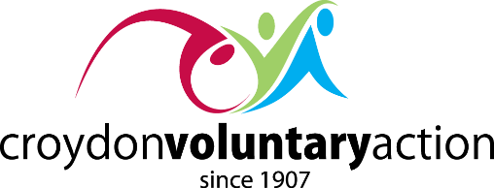

Croydon’s Community Hubs
Pathways Towards Social Support and Independence

1. Community Hubs in a nutshell

- Community Hubs provide pathways for people into social support networks, community-led activities and specialist voluntary (VCS) and statutory sector services

- Community Hubs are resident focused and community-led, with specialist VCS and statutory services supplementing the work

- Conversations held with residents at Community Hubs will be strengths-based and outcomes-focused with clear action plans being developed to achieve identified outcomes

2. How are Community Hubs different?

- One of the challenges for Community Hubs is in demonstrating how they reduce demand to statutory services and not create more ‘front-doors’

- To deliver transformational health and care work we are seeking to break service dependency and reduce demand on statutory services by providing community alternatives

- We are not seeking to break service dependency by creating substitute services to replace existing services

3. Building relationships not referrals

We can start building relationships when referrals to the Community Hubs are made by:

- Informing your resident (client/customer) of the Community Hub - where local residents are seeking to support other people living in the local area by providing information on local activities and services

- Advising your resident on the charity/faith group that the Hub is based at - let them know they can speak to paid practitioners and local volunteers in confidence who aim, in their roles, to support and work with residents at the Community Hub

- Attending the Community Hub with your resident - this can help build trust and confidence whilst breaking down barriers

Who can refer, signpost, or just come along to their Community Hub?

- Community Hubs are fully inclusive - any resident or paid practitioner can drop into a Community Hub to learn what it’s about and meet new people and paid workers who are placed based in the area

- Community Hubs seek to build on the strengths within communities and lean into the broad range of contacts and other assets in the local area. Residents can expect a listening ear but will be unequivocally informed of the capacities of the Community Hub in certain respects

- Where appropriate, residents will be offered signposting into other services/organisations that are better equipped to offer information, advice and guidance - i.e. Citizens Advice, ACAS, Crisis etc

What would be an inappropriate referral, something that a Community Hub is not designed for?

- Community Hubs are not offering a form filling service and can’t guarantee a fully insured welfare rights officer will be there to support with a comprehensive application

- Community Hubs can’t help people on issues that fall outside Health and Social Care and VCS funding remits. Two cases of the Community Hub having to kindly pass people on are:

Example 1: A person who may request a fully funded translator to deal with financial affairs
Example 2: A person who has been sent to have meet someone who can attend court appointments and mediation appointments with them

4. Conclusion - Focusing our goals on improving the health and wellbeing of residents in Croydon

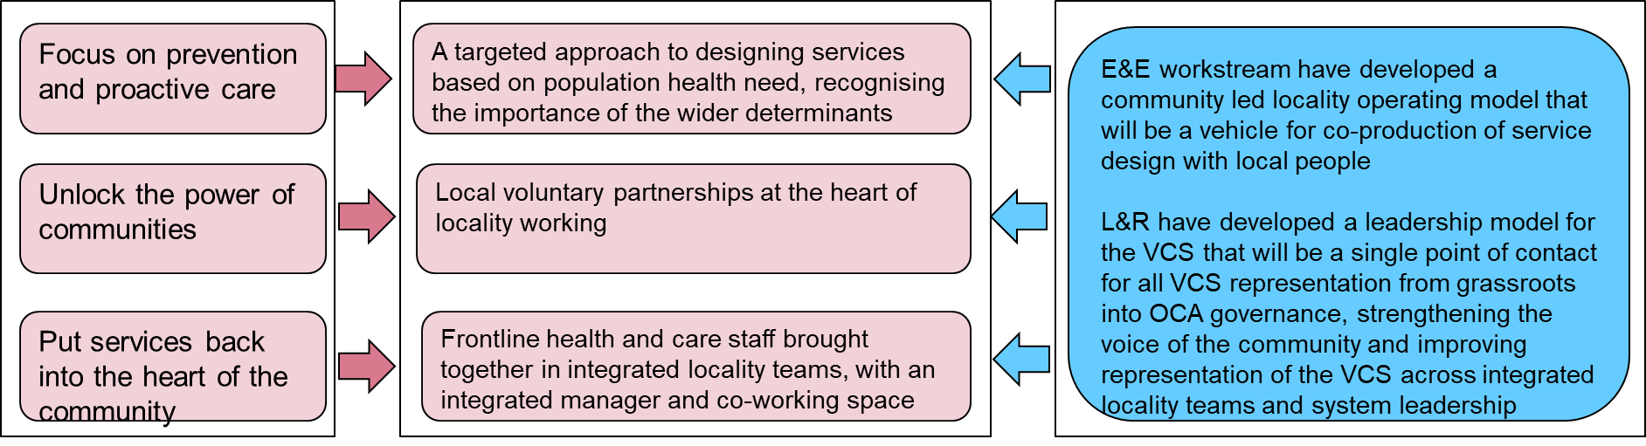

James Moore
Community Facilitator
Croydon Voluntary Action

